MODULE 1 — Anchor the Chain
When to use: Once, at the start. Before listing any events.
What it does: Establishes the two fixed endpoints of the chain (origin and market), identifies what units of measurement apply at each end, and produces a first-pass list of all change events and actors to investigate.
How to complete it: Answer each question in writing. Be precise. Resist the temptation to describe processes here — that happens in Module 2. This module is only about naming states and actors.

Material being analyzed: Senegal Ecosystems and agroforestry commodities. For project context re: Senegal ecosystems see:
https://claritycoalition.net/clarity-true-value-projects/truevalue-africa/serious-shea-burkina-faso-adapted-to-senegal/
Other references in the literature
https://www.researchgate.net/publication/386414777_Impact_of_Climate_Change_on_Millet_and_Maize_Yields_in_the_Agroecological_Zones_of_Senegal
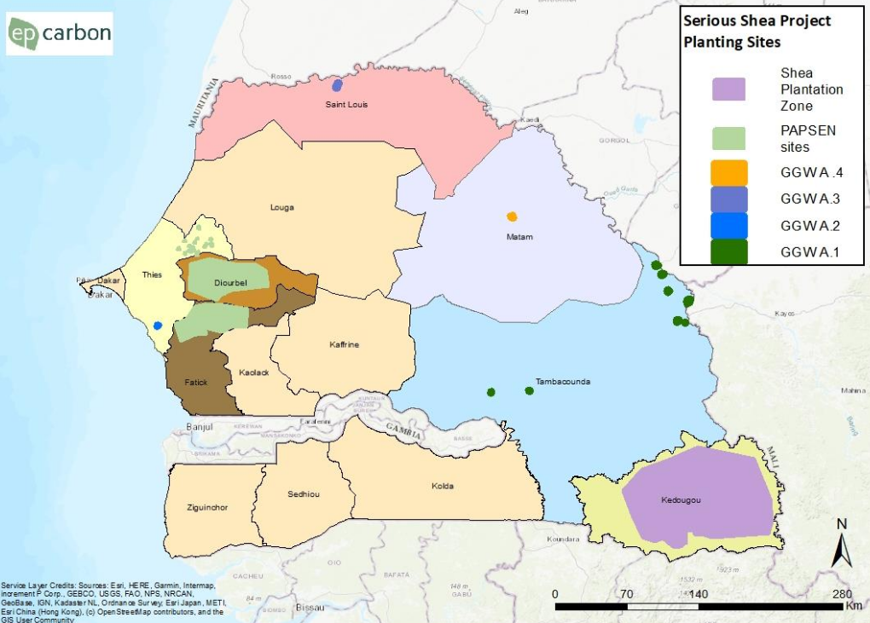

N.B. To map above helps visualise the Sengalese adminstration zones with respect to the Serious Shea Senegal Primary and Secondary Plantations and Shea Plantation Zone and the regions covered by the Serious Shea Senegal project investment plan (PAPSEN SITES and GGW A1 – 4). There is overlap between the Western Central Groundnut Basin where millet and other crops are also grown for PAPSEN (light green in the key and GGW2 marine blue in the key).
Copyright Serious Shea Senegal
Analyst name(s): Sarah Jones
Date completed: 8.6.26
Sources consulted for this module: See above links. Project Co-designer. Top Innovation, won The Sahel and The Great Green Wall Challenge in 2021 as the Serious Shea True Value Chain Project (Deforestation*free, Zero carbon, Beyond Fairtrade. Documents reference list provided. Endorsed by the World Economic Forum and their project selection experts and announced by the Undersecretary-General of the United Nations; Executive Secretary, United Nations Convention to Combat Desertification (UNCCD) Ibrahim Thiaw, announced today on 17 June 2021
https://claritycoalition.net/news/serious-shea-true-value-chain-wins-the-great-green-wall-challenge/
A0. What type of chain is this?
Select one There are three complementary chains as one supports livelihoods, one supports soil and ecosystems recovery with fertilization and energy generation, one supports potential carbon and nature credits, equity, and other ecosystem service investments). They shouldn’t be seen separately as the nurseries and plantations care and protection rely on sustainable rural communities with additional livelihoods from commodities.
- Forward — Nation wide ecosystems. Agroforestry commodities, Native Tree Nurseries and Plantations for carbon storage and sequestrion (carbon credits and equity). National scale crops depend on the ecosystems described in this research paper:

https://www.researchgate.net/publication/386414777_Impact_of_Climate_Change_on_Millet_and_Maize_Yields_in_the_Agroecological_Zones_of_Senegal
The Groundnut and millet cultivation region is heavily concentrated in west-central Senegal—a region known as the Groundnut Basin. This semi-arid, rainfed agricultural zone spans the administrative regions of Kaolack, Fatick, Thiès, Diourbel, and Louga, as well as parts of Kaffrine and Tambacounda. Sesame trees are also grown here.

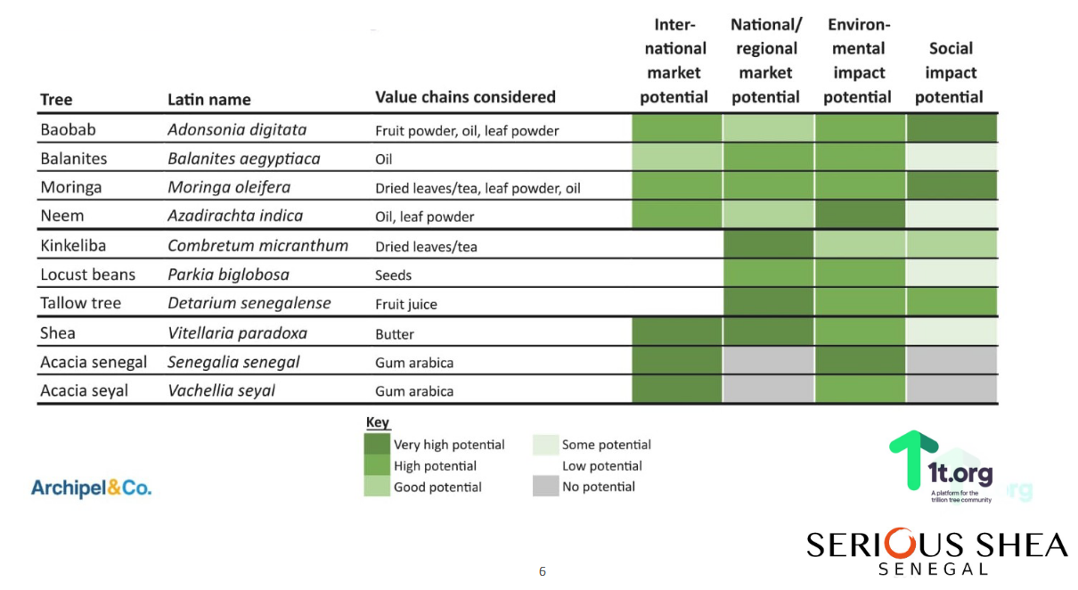
Serious Shea Senegal business plans is for 18 Multi-functional Clean Energy Processing Centres; 2 Shea Butter Processing Clusters and complentary nurseries and platantions for native forest restoration concentated in the areas identified in Busness Plan V8 of April 2023 see
https://claritycoalition.net/clarity-true-value-projects/truevalue-africa/serious-shea-burkina-faso-adapted-to-senegal/
Agroforestry commodity anchors for the Serious Shea project mutli-functional centres are Moringa, Mangos, and Shea in 2 clusters from the far east Savana region of the country.
Ecosystem servives from restored native forest are below and should be treated as ecosystem services provisioning by rain water and resored agro-forestry ecosystems – multi cropping and soil and biodiversity restoration for soil nutrients stability and water retention.
Plantations are two types 1. Primary consisting of native forest only and 2. Secondary consisting of native forest and the anchor crop moringa.

- Recycling — Recycling of all waste from processing for biogas (syngas), biochars, fertilizers, jams, water.
- Ecosystem — natural service chain (provisioning, regulating, cultural, biodiversity services). Origin and market states are defined by ecological rather than commercial endpoints.
If Recycling: this PDI documents the reverse chain as a standalone instrument. The primary forward chain is documented in a separate PDI instance.
1. Provisioning Services (Goods Produced)
- Fisheries: Marine and coastal waters—especially sardinella fisheries and small-scale artisanal fleets—employ ~600,000 people and account for 10.2% of exports. [1, 2]
- Agriculture & Agroforestry: The primary sector heavily depends on rainfall for staple crops like pearl millet, sorgum, maize, rice, groundnuts, legumes and root vegetables, sesame seeds. Traditional agroforestry parks (e.g., using Faidherbia albida or the "fertilizer tree") maintain soil fertility for millet, while néré and detarium trees provide fruits for daily livelihoods and local markets.
https://impress-impact-recherche.cirad.fr/our-activities/impress-ex-post/case-studies/groundnut-breeding accessed 08.06.26
See https://youtu.be/-ZHgDXguqPw?si=i-WB7RYaQkjbVLBF
Gender responsive Mangrove Restauration https://www.iisd.org/taxonomy/term/195
. Néré (Parkia biglobosa)
- Common Names: African locust bean tree, nété. [1, 2]
- Overview: A large, native deciduous perennial tree (typically 7–20 meters tall) belonging to the pea/legume family (Fabaceae). It features distinctive, fire-resistant dark bark and spherical red flowers that bloom in the dry season. [1, 2, 3]
- Key Uses:
  - Culinary: The yellow powdery pulp inside the seed pods is sweet and eaten fresh or made into drinks. The valuable seeds inside are processed and fermented to create a rich, savory seasoning paste or powder known as soumbala or dawadawa, which is a staple in West African soups and stews.
  - Medicinal & Agricultural: Various parts of the tree (leaves, bark, roots) are used in traditional pharmacology to treat ailments like malaria. Because it fixes atmospheric nitrogen, the tree is highly valued in agroforestry for restoring degraded soils and fertilizing nearby crops.
2. Detarium (Detarium)
- Common Names: Tallow tree, sweet detar, sweet dattock. [1, 2]
- Overview: A genus of deciduous leguminous trees containing three main species (Detarium microcarpum, Detarium senegalense, and Detarium macrocarpum) native across sub-Saharan Africa from Senegal to Sudan. [1, 2]
- Key Uses:
  - Culinary: They produce globular, green drupe fruits that contain a single seed and a fibrous, sweet-and-sour pulp. The pulp is exceptionally rich in Vitamin C (containing up to 29 times that of an orange) and is eaten fresh, cooked, or ground into flour.
  - Medicinal: The bark, leaves, and roots are widely utilized in traditional folk medicine to manage diabetes, malaria, wounds, and inflammation.
  - Ecological Value: Similar to néré, the deep horizontal root systems of Detarium trees are highly drought-tolerant, stabilize semi-arid soils, and help prevent erosion
Ground Nuts:
Senegal primarily grows peanuts (Arachis hypogaea), serving as its premier cash crop, alongside indigenous Bambara groundnuts (Vigna subterranea). Peanuts cover roughly half of the country's cultivated land.
Key Groundnut Varieties & Uses Oil-grade Peanuts: The bulk of the harvest (often grown in the central "Groundnut Basin") is processed locally by state-linked entities like SONACOS or exported for industrial oil pressing. [1, 2] Industrial/Commercial Groundnuts: Newer, large-scale commercial operations—such as SavanaNut located in the Saint-Louis Region—produce specialized groundnuts for domestic industrial processing. [1] Bambara Groundnuts: Grown by smallholder farmers across the region, this resilient, drought-tolerant legume is highly valued for subsistence farming and local nutritional security.
Ground nut paper 2026 https://www.cabidigitallibrary.org/doi/pdf/10.5555/20083326854
https://savananut.net/ accessed 08.06.26 see sesame as a key export product
https://cropsandsoils.extension.wisc.edu/bambara-groundnut/
https://pmc.ncbi.nlm.nih.gov/articles/PMC7758284/

- Timber & Fuel: Forests and mangroves provide vital timber, fodder, and firewood resources. [1, 2]
Deforestation of natural ecocoytems must be stopped and reversed with solutions such as mangrove and native forest nurseries and plantations financed by carbon credits and equity and biogas syngas, biochars, solar for energy and power.
2. Regulating Services (Benefits from Natural Processes)
- Coastal & Flood Protection: Mangroves in the Sine Saloum and Casamance deltas act as natural buffers against storm surges and rising sea levels. Undeveloped urban spaces (e.g., in Thiès) offer natural drainage and water retention capacity against urban flooding. [1, 2, 3]
- Water Management: Projects in the Niayes and Casamance regions focus on ecosystem restoration to prevent saltwater intrusion, reduce erosion, and improve water infiltration. [1]
- Carbon Sequestration: Both inland forests and mangrove restoration initiatives help mitigate climate change by absorbing carbon. [1, 2, 3]
3. Supporting & Cultural Services
- Nurseries & Biodiversity: Mangroves and seagrass beds act as essential nurseries for crustaceans and fish, sustaining both biodiversity and the economy. [1, 2]
- Ecotourism & Sanctuaries: Sites like the Djoudj National Park (a UNESCO World Heritage site) and Delta du Saloum National Park host millions of migratory birds, driving ecological tourism and global conservation significance.

A0b. Primary chain link (recycling chains only — skip for forward and ecosystem)
Which primary forward chain does this recycling chain feed back into, and at which phase(s) does secondary material re-enter?
Primary chain material: Anchor cash crop for export nationwide peanuts, and for Serious Shea Senegal centres and plantations moringa, mangos, shea, and from nurseries and plantations, biodiversity restoration and carbon storage and sequestration.
Re-entry phase number(s) in primary chain:
Processing waste for energy and fertilizer
Physical form and condition of material at re-entry: nut shells and husks, fruit discard

A1. What is the material in its pre-commercial state — before any human intervention?
Describe the physical form, location, and condition of the material as it exists in nature or at its origin point, before any extraction, harvest, or collection has occurred.
Answer: Natural forests, primary nurseries and plantations for natural forests, secondary plantations for natural forests together with moringa; mangoes and shea nuts on trees, ground nuts.

A2. What is the material at the point of final market delivery — what does the end buyer or end market actually receive?
Describe the physical form, specification, and condition of the material as it is transferred to the final purchaser or registered for market use.
Answer:
restores natural forests in situ
Moringa: leaves (fresh or powdered), pods (as vegetables), seeds (for oil and water purification), biomass (for fodder), and biochemical extracts (for medicine).
Mangoes:Dried
Shea Butter: raw for cosmetics/personal care products or fractionated into shea sterin for use in confectionary and food industry and shea olein the liquid portion for personal care products
Ground nuts:
Primary Food Products
- Direct Consumption: Kernels are consumed raw, boiled, or dry-roasted as snacks.
- Peanut Butter: A high-volume spread made by grinding roasted nuts.
- Confections: Used in peanut brittle, chocolate bars, and baked goods.
- Flour & Protein Powder: Defatted kernels milled into gluten-free, high-protein baking flour.
- Milk & Pastes: Blended into dairy-alternative plant milks or culinary pastes for sauces. [1, 2, 3, 4, 5]
Industrial & Edible Oils
- Groundnut Oil: Extracted for high-smoke-point cooking, cosmetics, and soap manufacturing.
- Extraction Yield: Standard hot-pressing methods extract roughly 50 kg of oil from 100 kg of raw peanuts. [1, 2, 3]
Agricultural By-Products
- Oil Cake/Meal: The protein-dense residue post-oil extraction, widely utilized in the Animal Feed Industry.
- Haulms (Vines): Highly nutritious livestock fodder containing 8% to 15% crude protein.
- Shells/Hulls: Used as biomass fuel, filler in fertilizer, or for manufacturing particle boards. [1, 2]

A3. What unit of measurement applies at the origin state (A1)?
Examples: tonnes of ore, hectares of crop area, cubic metres, number of animals, kilograms of raw material.
Unit kg ground nuts, moringa, mangoes, shea, hectares and canopy density of forestry plantations, number of seedling planted
A4. What unit of measurement applies at the final market state (A2)?
Examples: troy ounces of refined metal, kilograms of certified butter, litres of processed oil, standardised units.
Unit:Unit kg or litres oils, butter, powder, hectares and canopy density of forestry plantations, number of seedling planted and survive

A5. Are the units in A3 and A4 the same?
- Yes — the unit does not change across the chain for kgs and numbers of seedling planted though kgs of wet weight and dry weight are different re: moringa leaves, shea nuts, mangoes, ground nuts and again for powders and butter.
- No - the unit changes for litres of oil and no. of seedlings planted which survive. Also if biodiversity and ecosystem services regeneration, carbon storage and sequestration are converted to money credits, SLBs and other financial instruments
If No: note that at least one unit-change event exists somewhere in the chain. This is a strong signal of a phase boundary. Record where you believe it occurs — you will confirm it in Module 2.
Preliminary note on unit change location:

A6. List every distinct physical form the material passes through, between origin (A1) and market (A2).
Work from memory, documentation, or industry knowledge. Do not worry about completeness — this list will be refined in Module 2. Number each form.
# | Physical form | Approximate location in chain
1 | Ground Nut, Shea Fruit, Moringa leaves on trees  Mangoes on trees  Native forest seeds and seedlings | Pre collection, Pre planting
2 | Fruits and leaves collected, seeds planted | Harvesting, Collection, Planting
3 | Nuts, moringa seeds, peeled mangoes,  tree seedlings | Shelling, husk removal, nut extraction, nursery cultivation
4 | Leaves, nuts, dried mangoes, waste for shells and fruit waste for biogas syngas and fertilizers, seedlings planted in situ | Drying and Quality Control,
5 | Moringa Leaves and Powder, Moringa oil, Shea Paste | Grinding and Churning
6 | Shea butter fat, ground nut cake and oil | Steaming, Fat extraction, Pressing, Bulk packing, Exporting
7. | Shes Fractionation to Shea Sterin and Shea Olein | Eg Added to Cocoa for Chocolate or olein for personal care products
Add rows as needed.

A7. List every distinct actor class that holds or handles the material at any point in the chain.
Examples: miner, farmer, collector, trader, processor, refiner, certifier, logistics company, exchange, end buyer.
# | Actor class | Approximate point in chain
1 |  | Pre collection, Pre planting
2 | Collector, Farmer, Logistics, | Harvesting, Collection, nursery cultivation
3 | Processor, Trader. Logistics | Shelling, husk removal, nut extraction, plantation, waste recycling for energy and fertilizer
4 | Processor, certifier, logistics | Drying and Quality Control, plantation care
5 | Processor | Grinding and Churning
6 | Processor, logistics company, exchange | Steaming, Fat extraction, Pressing, Bulk packing, Exporting
7 | Processor, end buyer | Eg Added to Cocoa for Chocolate or olein for personal care products
8
Add rows as needed.

Module 1 — Completion Check
Before proceeding to Module 2, confirm:
- A1 and A2 are filled in with specific physical descriptions (not general statements)
- A3 and A4 have explicit units of measurement
- A6 has at least three distinct physical forms listed
- A7 has at least three distinct actor classes listed
If any box is unchecked, return to the relevant question before proceeding.

MODULE 2 — Event Inventory
When to use: After Module 1 is complete. Repeat this module once for every candidate event.
What is an event? An event is anything that changes any of the following: the physical form of the material, who holds it, where it is, what process is being applied to it, or who owns it. When in doubt, record it as an event — Module 3 will determine whether it rises to phase-boundary level.
How to identify events: Use the physical forms listed in A6 and the actor classes listed in A7 as your starting point. Each transition between forms is an event. Each transition between actor classes is an event. Add any additional events you identify through research.
How to complete it: Copy or reproduce this module for each event. Fill in every field. Where an answer is genuinely unknown, mark it UNKNOWN and note the reason. Do not leave fields blank.

Event Record
Event number: ___1____ of _______ total events identified
Event name / short description: Pre collection and planting

Sources consulted for this event: See all references e.g. Serious Shea Senegal Business Plan, EP Carbon Due Dilligence for Mirova Investment, Acorn materials

B1. What is the physical form of the material entering this event?
Answer: Ground Nut, Shea Fruit, Moringa leaves on tree, Sessame pods on trees
Mangoes on trees, Native forest seeds

B2. What is the physical form of the material leaving this event?
Answer: Harvested and collected raw fruit, leaves, pods, seeds planted

B3. Are B1 and B2 the same physical form?
- Yes — physical state is unchanged across this event Yes
- No — physical state changes across this event (flag: +1 toward boundary score)

B4. Does the unit of measurement change across this event?
Unit entering this event: kg of fruit, pods and leaves and number of seeds
Unit leaving this event:
- Yes — unit changes (flag: +1 toward boundary score)
- No — same unit throughout No

B5. What class of process is applied during this event?
Select one: Extractive
- Extractive — material is separated from its origin (mining, harvesting, collection)
- Aggregative — material is gathered, sorted, bulked, or first-traded without chemical change
- Chemical / Thermal — material undergoes chemical or thermal transformation (smelting, pressing, cracking, refining)
- Specification — material is brought to a defined standard or grade without changing its fundamental form
- Certification — material is tested, assayed, audited, or formally approved against a standard
- Custodial — material is stored or transported; no change in form, specification, or ownership
- Commercial — material is sold, registered, or delivered; change in legal status or market access
Notes on classification if ambiguous:

B6. Does the process class selected in B5 differ from the process class of the immediately preceding event? Process class of preceding event:First Event
- Yes — process class changes (flag: +1 toward boundary score)
- No — same process class continues

B7. Who physically holds the material immediately before this event begins?
Name the actor class, and the specific organisation or individual if known.
Actor class: Land owner
Specific name (if known): Great Great Wall and PAPSEN state (management of communities and cooperatives with fiscal rights) and private land owner (extract information from EP Carbon Due Dilligence).

B8. Who physically holds the material immediately after this event ends?
Actor class: Collectors, Nursery managers
Specific name (if known):GGW Projects managers, PAPSEN Project managers, Serous Shea partner coops and communities

B9. Are B7 and B8 the same entity?
- Yes — physical custody is unchanged
- No — physical custody transfers (flag: +1 toward boundary score) No

B10. Does legal ownership of the material change across this event?
- Yes — ownership transfers (flag: +1 toward boundary score)
- No — same owner before and after Yes owner becomes the harvester cooperative and Serious Shea planted seeds
- Unknown / unverifiable — note reason:

B11. Can you name a specific, measurable quantity that leaves this event — with a unit, a volume, and a named recipient?
This is the output test. The output must be definable, not estimated. "Approximately X tonnes" is acceptable. "It varies informally" is not.
- Yes (flag: +1 toward boundary score) — complete the fields below:
Quantity and unit: Extract infromation from Business Plan and EP Carbon Due Dillegence
Approximate volume (per year, per season, or per cycle):
Named recipient (actor class or specific entity):
- No — the output cannot be defined. Proceed to B12.

B12. If B11 is No: what is the reason the output cannot be measured?
Select one:
- (a) Informal practice — transactions occur but are not recorded in any accessible form
- (b) Commercial secrecy — data exists but is withheld by actors for competitive or legal reasons
- (c) Physical inaccessibility — the material or transaction is structurally unobservable (e.g. sub-surface, off-market, cross-border informal)
This classification is used in Module 4. Record it here for later use.

Event Record — Boundary Score Calculation
Transfer your flags from B3–B11 to the scoring table:
Criterion | Flag | Score
Physical state changed (B3 = No) | [ ] Yes / [ ] No
Unit of measurement changed (B4 = Yes) | [ ] Yes / [ ] No
Process class changed (B6 = Yes) | [ ] Yes / [ ] No
Physical custody changed (B9 = No) | [ ] Yes / [ ] No
Legal ownership changed (B10 = Yes) | [ ] Yes / [ ] No
Measurable output exists (B11 = Yes) | [ ] Yes / [ ] No
Raw boundary score (0–6): _______
Do not interpret this score yet. Interpretation occurs in Module 3, where all event scores are reviewed together.

Repeat this module for every event before proceeding to Module 3.

MODULE 3 — Boundary Scoring and Phase Map
When to use: After all Event Records (Module 2) are complete.
What it does: Applies a consistent scoring rule to every event, determines which events are confirmed phase boundaries, and produces the numbered phase map.
How to complete it: Transfer the boundary scores from all Event Records into the master table below. Then apply the interpretation rules. Phase numbers are assigned in sequence from origin to market.

Step 3.1 — Master Event Score Table
Transfer all events and their boundary scores here, in the order they occur in the chain:
Event # | Event name | Score (0–6) | B11 output defined? | Preliminary interpretation
 |  |  | [ ] Yes / [ ] No
 |  |  | [ ] Yes / [ ] No
 |  |  | [ ] Yes / [ ] No
 |  |  | [ ] Yes / [ ] No
 |  |  | [ ] Yes / [ ] No
 |  |  | [ ] Yes / [ ] No
 |  |  | [ ] Yes / [ ] No
 |  |  | [ ] Yes / [ ] No
 |  |  | [ ] Yes / [ ] No
 |  |  | [ ] Yes / [ ] No
Add rows as needed.

Step 3.2 — Apply Interpretation Rules
For each event, assign one of three interpretations using the following rules:
Rule 1 — Sub-process: Score 0–1, regardless of output status → this event belongs inside an existing phase, not at a boundary between phases. Record which phase it belongs to.
Rule 2 — Candidate boundary: Score 2–3 → review the B11 output field.
- If B11 = Yes (output is measurable): confirm as phase boundary.
- If B11 = No (output not measurable): classify as sub-process. A boundary without a definable output is structurally incomplete; the phase has not yet resolved into a stable N-state.
Rule 3 — Confirmed boundary: Score 4–6 → phase boundary confirmed regardless of B11, but B11 must be noted. If B11 = No at score 4+, the boundary is real but the transition point is opaque — record this explicitly.

Step 3.3 — Confirmed Phase Map
List only the confirmed phase boundaries below, in sequence. Number them starting from Phase 0 (origin/pre-commercial state) through the final phase.
Phase # | Phase name | Begins at (event #) | Ends at / transitions to (event #) | Child N output (from B11) | Re-entry phase (recycling only)
0 |  | —
1
2
3
4
5
6
7
Most supply chains resolve to 6–9 phases. Fewer than 5 suggests events have been grouped prematurely. More than 10 suggests sub-processes have been elevated to phase status.
For recycling chains: the "Re-entry phase" column records the primary forward chain phase number where this recycling phase's output material re-enters the primary chain. Only the terminal recycling phase (the one delivering secondary feedstock) typically carries a re-entry phase number. Earlier recycling phases leave this blank.
Note: Phase 8 is not a valid phase in this project's phase map. Recycling is documented as a separate chain_type: recycling PDI, not as a Phase 8 appended to any forward chain.

Step 3.4 — Sub-process Register
For events scored as sub-processes, record which phase they belong to:
Event # | Event name | Belongs to Phase # | Reason for sub-process classification

MODULE 4 — Opacity Tagging
When to use: After the Phase Map (Module 3, Step 3.3) is confirmed.
What it does: Assigns a transparency classification to each confirmed phase based on four measurability tests. This is not a qualitative judgment about the industry's trustworthiness — it is a structural assessment of whether each phase produces information that can be independently verified.
How to complete it: For each confirmed phase, answer the four questions below. Record the score and assign the classification. If data is genuinely unavailable to answer a question, answer No and note the reason — that itself is an opacity finding.

For each confirmed phase, complete one Opacity Record:

Opacity Record
Phase number: _______ Phase name: _______________________________________

C1. Can the volume throughput of this phase be measured from public sources?
Is there a publicly accessible data source (government statistics, exchange reports, industry association data, academic research) that gives an approximate quantity of material passing through this phase per year?
- Yes — source: ___________________________________________________________
- No — reason: ____________________________________________________________

C2. Can the identity of custodians in this phase be publicly established?
Can you name, or access a public list of, the specific organisations or actor classes that physically hold the material during this phase?
- Yes — source: ___________________________________________________________
- No — reason: ____________________________________________________________

C3. Can the transformation process in this phase be physically verified by an outside party?
Could an independent analyst, auditor, or regulator observe or confirm that the stated transformation is actually occurring and producing the stated output?
- Yes — mechanism: _______________________________________________________
- No — reason: ____________________________________________________________

C4. Can the child-N output of this phase — the handoff to the next phase — be independently confirmed?
Is there a way to verify, from outside this phase, that the output stated in Step 3.3 is the actual quantity and form being transferred to the next phase?
- Yes — mechanism: _______________________________________________________
- No — reason: ____________________________________________________________

C5. (Recycling chains only — skip for forward and ecosystem chains) Is the re-entry of secondary material into the primary chain documented with a traceable record?
At the phase identified in the "Re-entry phase" column of Step 3.3, is there a document, assay certificate, custody record, or registry entry that confirms secondary material entered the primary chain at the stated phase, in the stated quantity and form?
- Yes — source or mechanism: ______________________________________________
- No — reason: ____________________________________________________________
- N/A — this is a forward or ecosystem chain

Opacity Score and Classification
For forward and ecosystem chains — count Yes answers across C1–C4:
Yes count | Transparency classification | Meaning
4 | High | All four measurability tests pass. Phase is fully traceable.
2–3 | Medium | Partial traceability. Some structural gaps exist.
0–1 | Low | Phase is structurally opaque. The child-N transition cannot be independently traced.
For recycling chains — count Yes answers across C1–C5:
Yes count | Transparency classification | Meaning
5 | High | All five tests pass. Phase and re-entry fully traceable.
3–4 | Medium | Partial traceability. Re-entry linkage or internal process may be undocumented.
0–2 | Low | Phase is structurally opaque. Re-entry into primary chain cannot be independently confirmed.
Opacity score (Yes count): _______
Transparency classification: [ ] High [ ] Medium [ ] Low
Primary reason for opacity (if Medium or Low) — select from B12 categories recorded in Module 2:
- Informal practice
- Commercial secrecy
- Physical inaccessibility
- Multiple factors — describe: _______________________________________________

Repeat this Opacity Record for every confirmed phase before completing the Summary.

SUMMARY — Completed Phase Map
Complete this table after all four modules are finished. This is the deliverable.
Material: ___________________________________
Date completed: _____________________________
Analysts: ___________________________________
Phase # | Phase name | Physical state (in → out) | Child N output | Custodian class | Transparency
0
1
2
3
4
5
6
7
8

Total confirmed phases: _______
High transparency phases: _______ (Phase numbers: _______)
Medium transparency phases: _______ (Phase numbers: _______)
Low transparency phases: _______ (Phase numbers: _______)
Sub-processes identified and assigned: _______
Events where B11 output could not be defined: _______ (Opacity flags for further investigation)

Analyst Notes
Use this space to record any anomalies, contradictions between sources, events that could not be confidently classified, or areas requiring further research.

Phase Discovery Instrument v1.0 — True Value Analytics Aligned with: Abstract Supply Chain Phase Template | N-D-C Tholonic Framework

